​
Welcome to Bluebell Class Year 1

This year at Middlethorpe Primary Academy we have redesigned our curriculum. Our new knowledge based curriculum places powerful knowledge at its heart. The content has been chosen and carefully sequenced to build on prior learning. Each half term there will be a different subject focus. This half term the whole school will be focussing on History. To support children in their learning we have developed Knowledge Organisers for History and Science. Knowledge Organisers aim to help children retain and recall the essential knowledge that they are taught. Each Knowledge Organiser includes key dates, people, vocabulary, definitions, events and contextual or technical information that we want the children to know by heart by the end of the topic. Knowledge Organisers for each class can be found on the website but will also be sent home with the children for you to support them in learning the essential knowledge. We expect the majority of children to be able to recall all of the information on the Knowledge Organiser by the end of a half term.

In each subject we will be learning:
Science: Plants and seasonal changes
PE: Gymnastics
PSHE: Dreams and Goals
RE: Christianity
Music: Singing with Mrs Gooch
D&T: Making moving toy vehicles
AUTUMN TERM SUBJECT FOCUS
We will be focussing on History.
Our Enquiry question will be How has Cleethorpes changed over time?
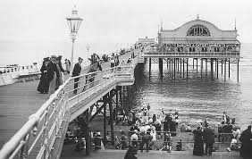

Follow us on Twitter
Year 1@middlethorpeprimary
English and Maths
English: Recounts
Traditional stories
Maths: Place Value, Length
Addition and subtraction
mmmm

Important Days
Our PE days are Monday and Thursday
We need to read 5 times a week and Reading Records will be checked on Monday . Reading books will be changed on Monday.
Library books will be changed on Friday
Spelling test will be on a Tuesday
Follow us on Twitter:

