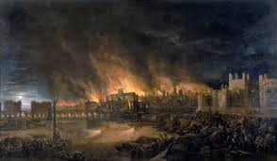
​
We are Bramble Class
Year 2 February/March 2020

Bramble class at Middlethorpe Primary Academy are excited to continue with our new knowledge based curriculum which places powerful knowledge at its heart. Each half term there is a different subject focus, this half term the whole school will be focussing on History. To support children’s learning we have developed Knowledge Organisers for History and Science, these aim to help children to retain and recall the essential knowledge that they will be taught. Each Knowledge Organiser includes key dates, people, vocabulary, definitions, events and contextual or technical information that we would like the children to know by heart by the end of the topic. Knowledge Organisers for each class can be found on the website but will also be sent home. We expect the majority of children to be able to recall all of the information on the Knowledge Organiser by the end of a half term. Follow us on Twitter to see what we are doing in class (see below).
SPRING TERM SUBJECT FOCUS
We will be focusing on History.
Our Enquiry question is:
What caused the great fire of London?

In each subject we will be learning:
Science: Animals including humans.
PE: Gymnastics flight and object control
PSHE: Healthy me
RE: Judaism
Music: Singing and percussion
D&T: Textiles- joining techniques.
ICT: Digital literacy- using a computer.

English and Maths
English: We are reading Katie in London by James Mayhew and The Great Fire of London by Emma Adams.
Maths: We will be practicing all four operations and fractions.
Follow us on Twitter:
@MPAClass2
Follow us on Twitter:

Important Days
Our PE days are Wednesday and Thursday. Children need to have their kit in school all week please in case of any timetable changes.
We all need to read 5 times a week and Reading Records will be checked when handed in weekly. Reading records will be stamped on a Monday.
Spelling test will be on a Monday. New spellings will be given out every Monday.
Singing club (choir) takes place on Thursday lunchtimes, for those who wish to attend.

