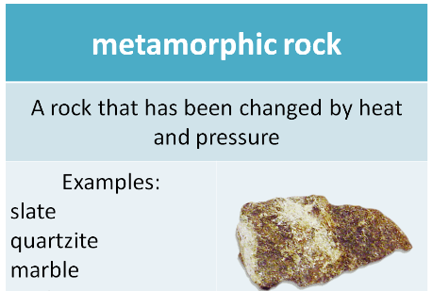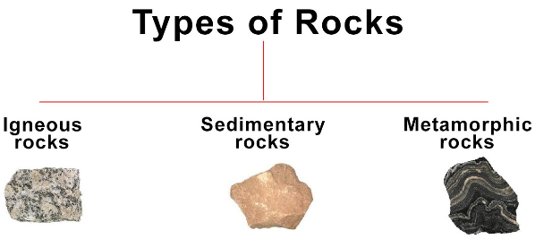

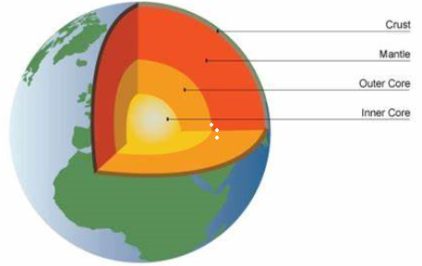

**YEAR 3: Science - Rocks Knowledge Organiser**

**Autumn Term 1**

The structure of the Earth

Key vocabulary:

**Earth igneous sedimentary**

**metamorphic manmade petrologist**

**molten rock magma lava fossil**

**What is the difference between magma and lava?**

Magma = molten rock below Lava = molten rock above

The Earth’s surface. the Earth’s surface.

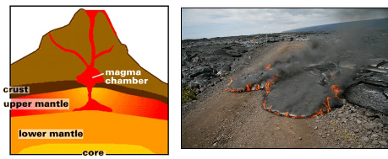

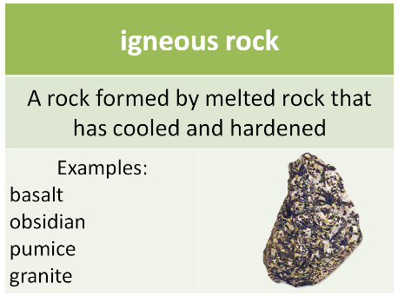

**Fossils** are remains of plants or animals that are formed in sedimentary rock.

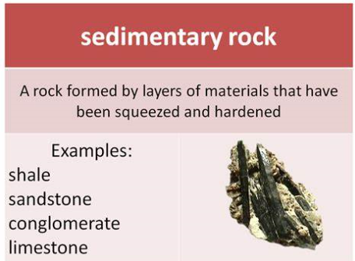

Can you identify any rocks around you?

Are they natural or man-made?

What type of rock might you see in a garden?

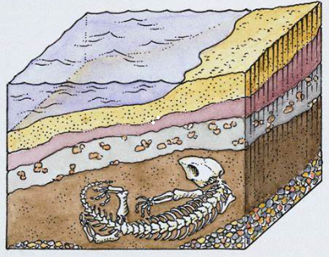

Bricks and cement are not found naturally, they are man-made.

